THE ILT SPINE ARTIFICIAL DISC
Next-Generation Total Disc Arthroplasty (TDA)
Clinical Benefits & Core Value Propositions
The ILT Spine Artificial Disc represents a milestone advancement in motion-preserving cervical spine surgery. Engineered to match natural cervical kinematics while simplifying the surgical workflow, it provides an advanced alternative to traditional anterior cervical discectomy and fusion (ACDF) for patients suffering from symptomatic cervical disc disease.

Key Clinical Benefits & Core Value Propositions
1. Advanced Physiological Motion Preservation
Unlike rigid fusion techniques that lock the vertebrae into a single static block, the ILT Spine Artificial Disc replicates natural segmental kinematics. It preserves full physiological motion across all major planes—including flexion, extension, lateral bending, and axial rotation—effectively maintaining the natural flexibility and biomechanical performance of the cervical spine.
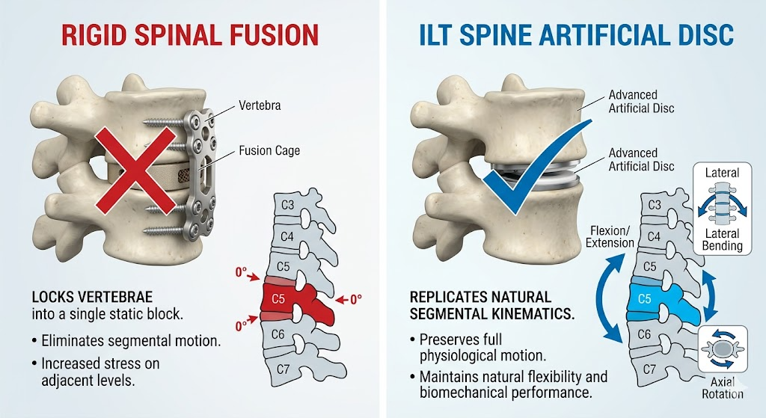

2. Targeted Reduction of Adjacent Segment Disease (ASD)
By maintaining normal segmental mobility and redistributing biomechanical loads appropriately at the index level, the ILT Spine Artificial Disc prevents the hyper-mobility and increased intradiscal pressures typically forced upon neighboring levels post-fusion. This directly lowers the long-term risk of adjacent segment degeneration and mitigates the need for secondary revision surgeries.
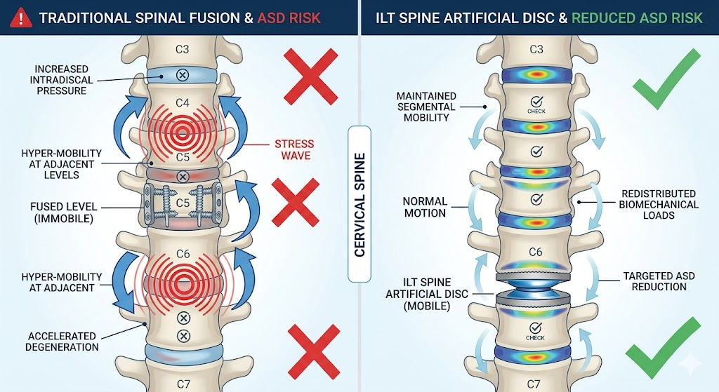

3. Elimination of Fusion-Related Morbidity
Because clinical success with the ILT Spine Artificial Disc does not rely on biological bone healing or osseointegration, surgeons can entirely eliminate common fusion-related complications:
- Zero Risk of Non-Union (Pseudarthrosis): Eradicates the primary clinical failure mode of standard ACDF procedures where the bone fails to bridge.
- No Bone Grafting Required: Eliminates the necessity for autograft harvesting (e.g., iliac crest) or expensive synthetic bone graft substitutes, drastically reducing donor-site pain and overall patient morbidity.
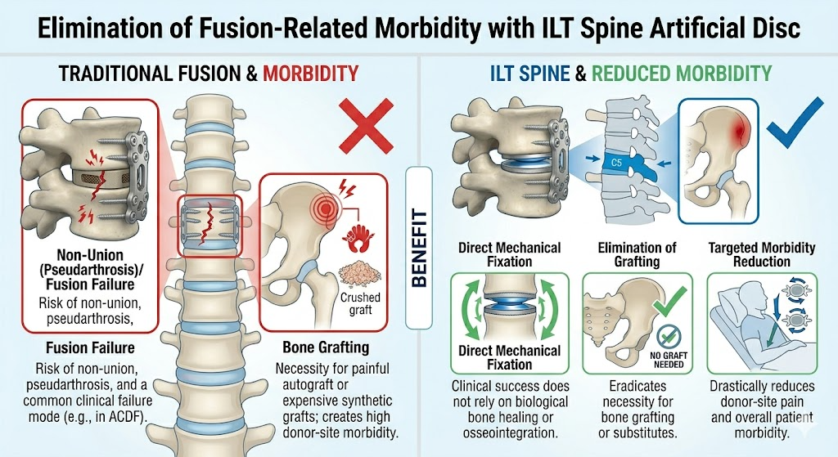

4. Low-Profile Design to Minimize Postoperative Dysphagia
Featuring an ultra-low, anatomic footprint restricted strictly to the intervertebral space, the ILT Spine Artificial Disc avoids the use of bulky anterior plating systems. This significantly minimizes physical irritation to the surrounding prevertebral soft tissues and esophagus, drastically reducing the incidence and severity of transient or chronic postoperative dysphagia (difficulty swallowing).
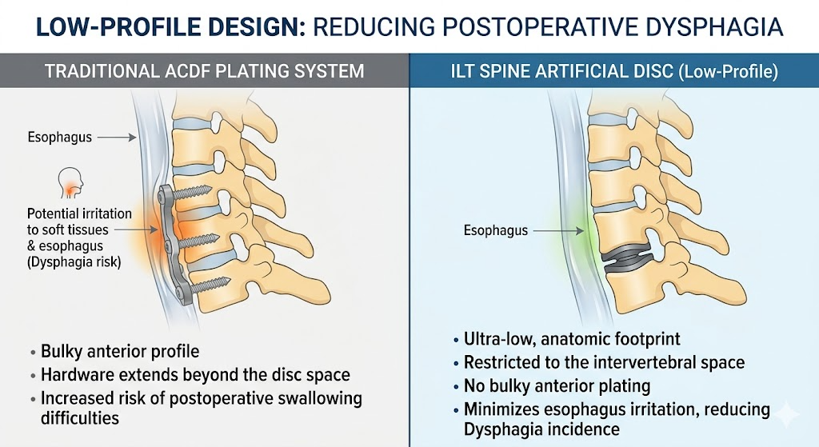

5. Accelerated Patient Recovery and Mobilization
- No Rigid Post-Op Collars: Immediate mechanical stability achieved by the smart implant design allows patients to bypass uncomfortable, rigid neck braces entirely.
- Early Functional Rehabilitation: Supports controlled, early range-of-motion exercises post-surgery, leading to faster functional recovery, minimized muscle atrophy, and a swift return to daily activities.
